Fall Detection Systems in Public Spaces
By Eden Amram, Ziv Shamli

Introduction
According to the World Health Organization (WHO), falls are the second leading cause of unintentional injury-related deaths worldwide. Each year, the WHO estimates that approximately 37.3 million individuals experience falls severe enough to require medical attention, underscoring the substantial global health burden associated with this issue. National-level data support this observation: a 2024 study titled Clinical trauma severity of indoor and outdoor injurious falls requiring emergency medical service response reported that in the United States alone, 1,854,909 fall incidents in 2019 required emergency medical services (EMS).
The study found that nearly 85% of fall events occur indoors, however, a meaningful proportion also occurs outdoors: in parks, sidewalks, and roadways. These outdoor environments introduce additional challenges such as uneven terrain, varying lighting conditions, environmental obstacles, and the presence of other people in the background. Such factors create complex real-world scenarios that significantly complicate fall-detection tasks.
A recent systematic review, Deep Learning for Computer Vision based Activity Recognition and Fall Detection of the Elderly (2024), further highlights major limitations in current research. Most existing fall-detection models achieve high performance only in controlled indoor environments, while their accuracy deteriorates in uncontrolled settings such as outdoor areas, crowded spaces, and low-light conditions. The review emphasizes that nearly all publicly available fall-detection datasets are collected in laboratory-controlled indoor environments, characterized by stable lighting, fixed camera positions, clean backgrounds, and scripted fall scenarios performed by healthy individuals. As a result, current datasets lack the visual diversity necessary for robust real-world generalization.
Additionally, the review notes that many proposed deep learning architectures are computationally heavy, making them impractical for real-time deployment, especially on resource-constrained edge devices. In real-world applications, fall-detection systems must operate with minimal latency to provide timely alerts, which requires lightweight and efficient models capable of real-time inference without sacrificing accuracy.
Developing such systems also requires large, diverse, and realistic datasets, covering a wide range of lighting conditions, backgrounds, camera angles, human appearances, and dynamic environments. However, collecting large-scale real-world fall data manually is impractical due to safety constraints, time limitations, and high costs. Consequently, recent research highlights the growing need to leverage generative models, such as diffusion-based architectures, to synthesize realistic and diverse fall-related images. These generative techniques can significantly augment existing datasets, increase visual variability, and improve the generalization and robustness of fall-detection models in real-world scenarios.

Related Works
There are various types of generative models for creating realistic images, including Text-to-Image models and models designed for integrating objects into existing images (Object Compositing). These models enable the generation of new, visually accurate images, whether based on textual descriptions or through object integration, while maintaining consistent details and a coherent scene. In this study, generative models were used to create realistic images of falls in public spaces, with the aim of producing data for training and evaluating fall detection models.
A comparative study conducted in “Perception and Evaluation of Text-to-Image Generative AI Models” examined the performance of four leading models: OpenAI’s DALL-E, Google’s Imagen, Stable Diffusion, and GROK AI. The study combined quantitative evaluation using metrics such as FID, SSIM, and PSNR with human evaluation in a survey of 28 participants, aiming to assess the perceived realism of the generated images.
DALL-E, based on a Transformer architecture with VQ-VAE-2 for creating a discrete latent space, showed high performance in both quantitative metrics and user evaluation, demonstrating the ability to generate diverse and complex images. Imagen, Google’s closed diffusion model, excelled in producing photorealistic and accurate images, with participants rating its outputs as nearly as realistic as real photographs. In contrast, open models such as Stable Diffusion and GROK showed lower performance, with higher FID scores and lower perceived realism.
In the context of object integration into existing images, the study by Song et al. (2024) introduced IMPRINT, an innovative Generative Object Compositing framework. The model focuses on preserving object identity and harmonizing with the background, applying a two-stage strategy: the first stage involves Context-Agnostic ID-Preserving Pretraining using a DINOv2-based encoder to learn view-invariant representations and preserve instance-level details; the second stage performs Compositing & Harmonization with fine-tuning of the Stable Diffusion UNet, including integration of the object embedding in cross-attention layers and additional techniques to improve harmonization and control object shape.
Experiments with IMPRINT showed superior performance compared to existing models such as Paint-by-Example, ObjectStitch, and TF-ICON. Quantitative metrics indicate significant advantages: FID = 16.45, indicating high realism; CLIP-score = 96.19, reflecting optimal object identity preservation; DINO-score = 94.71, showing precise visual detail retention; and DreamSim = 0.083, indicating close alignment with perceived realism by users. In a user survey, 73–86% preferred IMPRINT in terms of object fidelity and image realism.
From the analysis of the findings, several key trends can be identified: first, industrial Text-to-Image models (DALL-E, Imagen) exhibit high realism and diverse image generation capabilities; second, Object Compositing models allow realistic integration of objects while preserving their identity and scene consistency; third, combining quantitative evaluation with human assessment is essential for evaluating generative model performance; and finally, there is a significant gap between large industrial models and open models, particularly regarding realism and visual detail preservation.
There are different approaches to human fall detection, with some methods processing each frame individually, while others analyze a sequence of frames to detect abnormal movement patterns. The choice of approach affects not only the detection accuracy under challenging conditions, such as low lighting, complex backgrounds, or partial occlusions, but also the processing speed, which is critical for real-time applications on edge devices.
Zhang et al. (2022) in “Visual Surveillance for Human Fall Detection in Healthcare IoT” present a visual monitoring system designed for integration into healthcare IoT infrastructures. The system operates in two main stages: first, it tracks the person using motion detection and gait analysis. Second, it analyzes body posture by calculating angles, curvatures, and rapid changes in body position. The system uses a model such as OpenPose to detect body keypoints in each frame, which are then connected to form a skeleton representation. From the skeleton, features such as body angles, leg angles, and height–width ratio are computed to detect falls and abnormal postures. Advantages of this approach include robustness to background noise and partial occlusions, low dependency on color or texture, and high accuracy under good lighting conditions (up to 98.4%). Limitations include poor performance in low-light environments, high computational requirements (GPU), and the risk of false alarms, particularly in complex scenes.
Zi et al. (2023) in “Detecting Human Falls in Poor Lighting: Object Detection and Tracking Approach for Indoor Safety” focus on fall detection in low-light environments. The system includes preprocessing to isolate the body and reduce background noise, feature extraction using an object detection model (YOLO) to learn the appearance and current posture of the person in each frame, and a temporal model based on LSTM/GRU that analyzes a sequence of frames to understand movement: standing → losing balance → falling. Advantages of this approach include understanding movement over time, noise reduction, and higher accuracy compared to single-frame models. Limitations include higher computational requirements, the need to analyze multiple frames, and sensitivity to occlusions, for example, when the person is partially hidden behind furniture, accuracy decreases.
Nabizade et al. (2025) in “Fall Detection Using LBFD-Net: A Novel CNN-Based Architecture” introduce a lightweight CNN called LBFD-Net for real-time fall detection. The model was trained on a combined dataset of 18,316 labeled images from four different datasets, balanced between fall and non-fall images. The architecture includes convolutional and residual blocks, global average pooling to create a compact feature vector, and a fully connected layer with a sigmoid output to estimate the probability of a fall. The model achieved high accuracy (99.59%), low resource requirements, and was both lighter and more efficient compared to classical models such as AlexNet and LeNet. Limitations include processing single frames only (without temporal information), training only in controlled environments, and no training on low-light or outdoor images. In our study, we plan to use this network due to its high accuracy, lightweight design, and real-time capability on edge devices.

Research Question
"How does training with generative images of outdoor and crowded environments impact the generalization, accuracy, sensitivity, and robustness of a fall detection model across indoor and outdoor settings?"
Datasets:
- URFD
The dataset contains 289 fall images and 363 non-fall images (normal activities). The images were extracted from video sequences captured with RGB and Depth (Kinect) cameras. All samples were recorded indoors under bright and controlled lighting conditions.
Link: URFD Dataset
- UP-Fall
The dataset includes 17 participants (9 males, 8 females) aged 18–24. Each participant performed 11 activities (6 daily activities and 5 falls), each repeated three times. All recordings were captured with RGB cameras under bright and controlled lighting conditions.
Link: UP-Fall Dataset
- Le2i
The dataset contains 208 images from 13 different scenes. Half of the images (104) depict falls, and the other half (104) show normal activities. Images were captured in various environments (living rooms, meeting rooms, corridors, etc.) and from different angles. Lighting conditions were bright and controlled.
Link: Le2i Dataset
- MultiCam
The dataset includes 24 video clips of falls as well as videos of normal activities. Recordings were made simultaneously with 8 different cameras to capture events from multiple angles. All recordings were conducted under bright and controlled lighting, with variations in lighting angles only.
Link: MultiCam Dataset

Methodology
This research consists of two main phases.
Phase 1 focuses on evaluating generative models and creating a synthetic dataset representing public-space fall scenarios, addressing the lack of real-world outdoor fall data.
Phase 2 evaluates the performance and generalization capabilities of LBFD-Net under different training conditions, using both real laboratory data and synthetic data.

Phase 1: Generative Model Evaluation and Synthetic Dataset Creation
Due to the lack of publicly available real-world fall datasets collected in outdoor or crowded environments, this study first focused on generating synthetic fall images using advanced generative AI models. The goal was to identify the most suitable Text-to-Image, Image-to-Image and inpainting models capable of producing realistic fall and non-fall scenes in public spaces such as streets, sidewalks, and parks.
Two evaluation tracks were conducted:
Track A: Text-to-Image
In this track, each model generated 10 images based on the same textual description of a fall event in a public space. The generated images were evaluated using a combination of physical and perceptual metrics, with primary emphasis on metrics reflecting physical consistency and 3D spatial coherence.
Physical Metrics (High Priority)
- Depth Consistency - Measures the spatial coherence of scene depth, particularly maintaining the relative positions of characters, background, and objects. This metric assesses whether body poses and falls are integrated logically within the 3D scene.
- Shading Consistency - Evaluates the alignment of shadows with scene lighting, including direction, intensity, and placement. This metric is critical for identifying physical inconsistencies, such as shadows that do not correspond to body pose or light direction.
- Normals Consistency - Assesses the consistency of surface normals, i.e., the orientation of surfaces and objects in the scene. This metric ensures that objects and human figures are physically plausible and free from geometric distortions.
These metrics were prioritized as they capture the physical and structural fidelity of the scene, a key requirement for datasets intended to train fall detection models.
Perceptual Metrics (Secondary Priority)
After evaluating physical consistency, images were further assessed using reference-free perceptual metrics:
- NIQE - Measures how closely an image conforms to the statistical properties of natural images.
- BRISQUE - Evaluates spatial quality and local distortions without requiring a reference image.
- MA Score - Assesses aesthetic quality and visual composition.
Evaluation Hierarchy
- Physical consistency metrics (Depth, Shadowing, Normals)
- NIQE
- BRISQUE
- MA Score
This evaluation framework ensures that the selection of a generative models prioritizes physical plausibility and structural coherence of the scenes, followed by perceptual and aesthetic quality.
Track B: Image-to-Image
In this setup, each model generated 10 images based on reference images depicting a person falling or not, in public spaces. The aim of the analysis was to evaluate the realism and physical consistency of the images produced by the generative models. Although reference-based metrics such as KID, PSNR, and SSIM are commonly used to assess image fidelity, they are not suitable in this context. While the generation process uses a reference image, the resulting images contain new and significant content that differs from the original. Consequently, these metrics tend to yield low scores, reflecting differences that do not indicate poor quality but rather legitimate variation in the scene.
To better evaluate the generated images, we prioritized physics-based metrics, followed by perceptual quality assessment:
Physical Metrics (High Priority)
- Depth Consistency - Measures the spatial coherence of scene depth, particularly maintaining the relative positions of characters, background, and objects. This metric assesses whether body poses and falls are integrated logically within the 3D scene.
- Shading Consistency - Evaluates the alignment of shadows with scene lighting, including direction, intensity, and placement. This metric is critical for identifying physical inconsistencies, such as shadows that do not correspond to body pose or light direction.
- Surface Normals Consistency (Normals)- Assesses the consistency of surface normals, i.e., the orientation of surfaces and objects in the scene. This metric ensures that objects and human figures are physically plausible and free from geometric distortions.
Secondary perceptual metric
- NIQE - Measures how closely an image conforms to the statistical properties of natural images.
This evaluation framework emphasizes realism, physical plausibility, and structural consistency, while maintaining overall perceptual quality, providing a reliable basis for selecting the best models for Image-to-Image tasks.
Track C: Inpainting-Based Image
In this track, an inpainting-based approach was employed to generate realistic fall and non-fall images in public-space environments.
First, ten source images containing a human subject (fall and non-fall scenarios) were selected. YOLO combined with SAM was used to detect and segment the person, and a mask was generated to isolate the human region.
Public-space background images were then selected as target scenes. The masked person was integrated into the background image, after which an inpainting model was applied to complete the surrounding regions. The model ensured consistency in lighting, perspective, texture, and overall scene context.
As a result, the generated images depict individuals naturally embedded within public-space environments.
To better evaluate the generated images, we prioritized physics-based metrics, followed by perceptual quality assessment:
Physical Metrics (High Priority)
- Depth Consistency - Measures the spatial coherence of scene depth, particularly maintaining the relative positions of characters, background, and objects. This metric assesses whether body poses and falls are integrated logically within the 3D scene.
- Shading Consistency - Evaluates the alignment of shadows with scene lighting, including direction, intensity, and placement. This metric is critical for identifying physical inconsistencies, such as shadows that do not correspond to body pose or light direction.
- Surface Normals Consistency (Normals)- Assesses the consistency of surface normals, i.e., the orientation of surfaces and objects in the scene. This metric ensures that objects and human figures are physically plausible and free from geometric distortions.
Secondary perceptual metric
- NIQE - Measures how closely an image conforms to the statistical properties of natural images.

This evaluation framework emphasizes realism, physical plausibility, and structural consistency, while maintaining overall perceptual quality, providing a reliable basis for selecting the best models for inpainting tasks.

Synthetic Dataset Generation
In this stage of the methodology, the top-performing generative models selected in the previous phase, both Text-to-Image and Image-to-Image and Inpainting were used to create synthetic datasets for training and evaluating the LBFD net fall detection model. Each selected model generated an independent dataset consisting of 300-330 labeled images. In this way, each generative model produced a unique dataset, reflecting the style and characteristics of that specific model.
The synthetic images depict fall and non-fall scenarios across a wide range of public environments. They were designed to include significant variations in several key aspects:
- Background complexity - from simple to complex backgrounds with varying elements.
- Lighting conditions - natural and artificial lighting with different intensities and directions.
- Camera angles - multiple viewpoints to represent different perspectives.
- Human poses and crowd presence - diverse human poses, including single individuals and crowded scenes.
All images were manually labeled by the researchers, ensuring high accuracy in distinguishing fall from non-fall scenarios. The resulting synthetic datasets were used for fine tuning and testing the LBFD net model, aiming to evaluate model performance across diverse scenarios and ensure high generalizability in various conditions.
This approach allows a thorough assessment of the impact of the generative model type on the quality of the synthetic datasets, the realism of the images, and the model’s performance in different environments.

Phase 2: Fall Detection Using LBFD-Net
The second phase of this study focuses on evaluating the impact of synthetic data generated by different generative models on the performance of the LBFD-Net fall detection model. This evaluation is conducted through a controlled fine-tuning process and a unified testing protocol, aiming to examine how the type of synthetic data influences the model’s detection and generalization capabilities across different environments.
Datasets
Four distinct data sources are used in this phase. The first is a synthetic dataset generated using inpainting techniques, in which human figures representing fall and non-fall scenarios are embedded into existing public-space scenes while maintaining visual and physical consistency. The second dataset is generated using Stable Diffusion and includes a wide range of public environments such as streets, sidewalks, and parks, characterized by high variability in lighting and background complexity. The third synthetic dataset is produced using the Nano Banana generative model, emphasizing increased visual diversity and stylistic variation. In addition, a real indoor laboratory dataset containing fall and non-fall scenarios is used as a realistic reference.
LBFD-Net Fine-Tuning
The base model for all experiments is LBFD-Net pretrained on the indoor dataset. This pretrained model serves as a common initialization point for all fine-tuning experiments to ensure a fair and controlled comparison. Fine-tuning is then performed separately on each synthetic dataset, as well as on a combined dataset containing all synthetic images. All fine-tuning processes are conducted independently while using the same training protocol and identical hyperparameters.
Training Process
Training is implemented using the PyTorch framework and optimized with the Binary Cross-Entropy with Logits loss function. The Adam optimizer is employed with a learning rate of 5×10⁻⁵ and no weight decay, and a StepLR scheduler is used to reduce the learning rate every four epochs. The batch size is set to 16. Each training iteration consists of a forward pass, loss computation, backpropagation, and parameter updates, with the training loss averaged per epoch.
Validation and Model Selection
Validation is performed once per epoch and includes the computation of loss values and performance metrics such as accuracy, precision, recall, and F1-score. The final model is selected based on the lowest validation loss, and early stopping is applied to mitigate overfitting.
Test Sets Design
Each model is evaluated using a dedicated test sets that combines real indoor images not seen during training with synthetic images generated by the same generative model used for fine-tuning. For example, a model fine-tuned on Stable Diffusion is evaluated on a test set consisting of both real indoor data and images generated by Stable Diffusion. In addition, we constructed an additional general test set for a more comprehensive evaluation, which includes images from all generative models as well as images from the indoor dataset, providing a complementary assessment. This testing strategy enables precise evaluation of the model’s performance on real data while also measuring its alignment with the broader synthetic domain.
Evaluation Metrics
Model performance is evaluated using classification metrics, including accuracy, precision, and F1-score, as well as curve-based analysis through the ROC curve and the AUC metric, which provides a threshold-independent measure of performance.

Result

Results – Stage 1: Evaluation of Text-to-Image Models
In this stage, generative Text-to-Image models were evaluated to identify the most suitable model for generating realistic images of human falls in public spaces, without relying on reference images. Three diffusion-based models were examined: Stable Diffusion v1.5, Stable Diffusion XL (with VAE), and Kandinsky 2.2. In addition, the Nano Banana model was included for comparison.
Each model generated 10 images based on the same textual description of a fall scenario occurring in a public environment.
To assess physical plausibility and structural realism, physics-aware consistency proxies were first employed. These included Depth Consistency, Shading Consistency, and Surface Normals Consistency, which capture geometric structure, illumination coherence, and surface orientation stability, respectively. Based on empirical observations and prior work, images considered realistic are expected to fall within the following ranges:
- Depth mean: 0.30 – 0.45, indicating coherent spatial structure and reasonable depth ordering.
- Shading mean: 0.45 – 0.60, reflecting consistent lighting and physically plausible shadow behavior.
- Surface Normals mean: 0.015 – 0.030, suggesting stable surface geometry without excessive noise or artifacts.
Following the physical consistency analysis, overall perceptual image quality was evaluated using no-reference image quality metrics: NIQE, BRISQUE, and MA Score. According to the literature, high-quality and realistic images are typically characterized by a NIQE value below 3, a BRISQUE value below 20, and an MA Score close to 10, which respectively indicate naturalness, spatial quality, and visual aesthetics.
The quantitative results are summarized in Table 1.

Quantitative Results

Models | Depth C. | Shading C. | Normals C. | ↓NIQE | ↓BRISQUE | ↑MA Score
Stable Diffusion v1.5 | 0.39 | 0.444 | 0.03 | 3.271 | 17.474 | 5.862
Stable  Diffusion | 0.37 | 0.54 | 0.0298 | 3.824 | 33.675 | 5.864
Stable Diffusion XL | 0.37 | 0.446 | 0.037 | 3.764 | 15.504 | 5.789
Kandinsky 2.2 | 0.346 | 0.428 | 0.033 | 4.495 | 36.117 | 6.094
Nano Banana | 0.371 | 0.514 | 0.031 | 2.686 | 22.225 | 5.778
Table 1 : Evaluation of text-to-text models

Visual Results
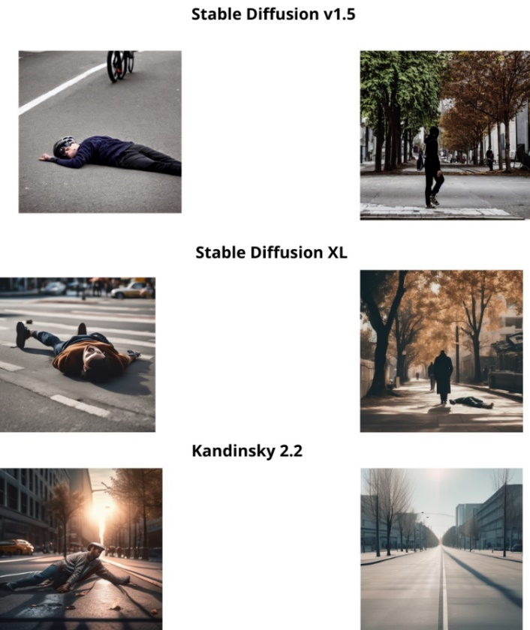

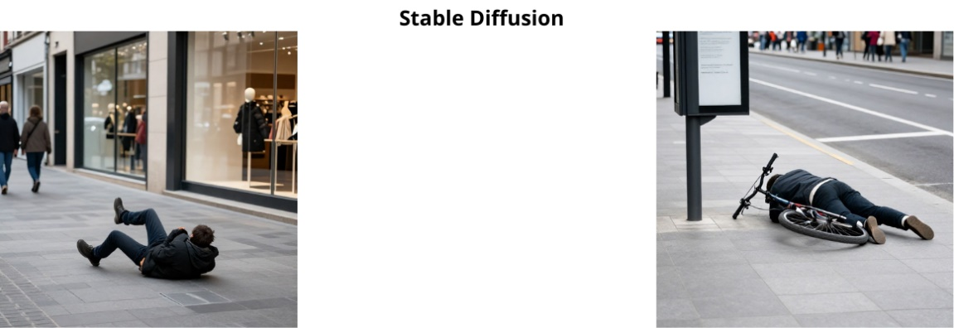

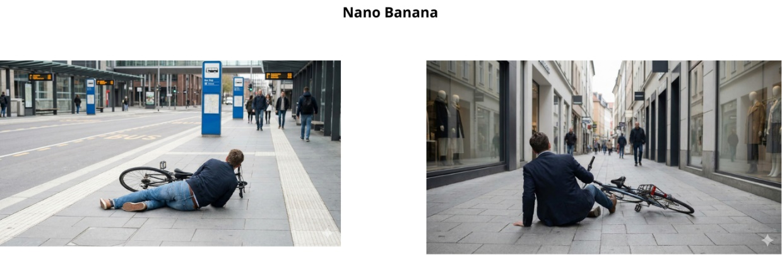

Results Analysis
According to the defined evaluation priority, first physics-aware consistency metrics (Depth, Shading, and Surface Normals), followed by NIQE, then BRISQUE, and finally MA Score , Nano Banana was identified as the top-performing generative model. The model demonstrates well-balanced physical consistency, with Depth and Shading values falling comfortably within the defined realism ranges. Notably, it achieves the highest shading consistency among all evaluated models, indicating coherent lighting and shadow behavior, while its surface normals consistency is close to the desired upper bound, reflecting stable geometric structure.
In addition, Nano Banana attains the lowest NIQE score and is the only model that meets the commonly accepted threshold for high-quality images, indicating superior visual naturalness. Although its BRISQUE score is slightly above the ideal threshold, this metric is assigned lower priority in the evaluation hierarchy and therefore does not significantly impact the overall assessment. The MA Score is comparable to those of the other evaluated models, suggesting similar perceived visual aesthetics.
However, despite its strong overall performance, the use of Nano Banana is associated with higher computational and financial costs. Due to budget constraints, a practical trade-off was required for subsequent stages of the study. Stable Diffusion, which demonstrated competitive performance across both physical consistency and perceptual quality metrics, was therefore selected as an alternative generative model. While slightly inferior to Nano Banana in certain high-priority metrics, Stable Diffusion still provides a reliable balance between realism and resource efficiency.
Consequently, Nano Banana is identified as the best-performing model from a purely qualitative perspective, whereas Stable Diffusion was adopted for downstream experiments as a cost-effective and sufficiently robust solution, enabling large-scale synthetic data generation within the constraints of the study.

Results – Stage 1: Evaluation of Image-to-Image Models

Quantitative Results

Models | Depth C. | Shading C. | Normals C. | ↓NIQE
Stable Diffusion v1.5 | 0.31 | 0.479 | 0.273 | 2.372
Stable Diffusion XL + VAE | 0.31 | 0.51 | 0.033 | 6.431
Masked Stable Diffusion XL | 0.31 | 0.51 | 0.033 | 5.903
ChatGPT 5 | 0.454 | 0.348 | 0.044 | 4.945
Nano Banana | 0.31 | 0.491 | 0.028 | 2.536
Table 2: Evaluation of image-to-image models

Visual Results
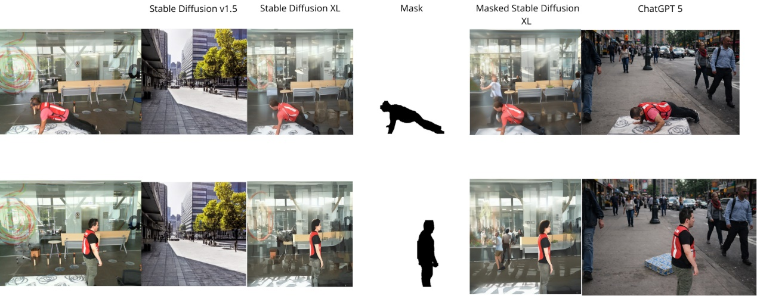
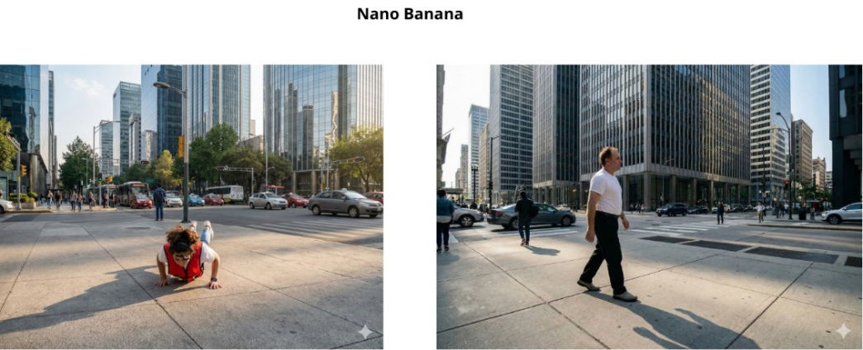

Results Analysis
Based on the physics-aware consistency metrics and NIQE, Nano Banana demonstrates the most balanced and superior performance among the evaluated models. Its Depth and Shading values fall within the realistic range, indicating good preservation of spatial structure and coherent lighting and shadow behavior, while its Surface Normals value is close to the desired upper bound, reflecting stable geometry without excessive noise. In contrast, Stable Diffusion v1.5 shows excessively high Normals, ChatGPT-5 exhibits increased Depth and less consistent shading, and Stable Diffusion XL + VAE and Masked SDXL have high NIQE values, indicating lower visual naturalness. The low NIQE value of Nano Banana (2.536) reflects high visual naturalness, combining physical realism and visual quality, making it the preferred choice for generating realistic synthetic images of falls in public spaces.

Results – Stage 1: Evaluation of Inpainting Model

Quantitative Results
Models | Depth C. | Shading C. | Normals C. | ↓NIQE
inpainting | 0.363 | 0.497 | 0.031 | 3.158
Table 3: Evaluation of the inpainting model

Visual Results
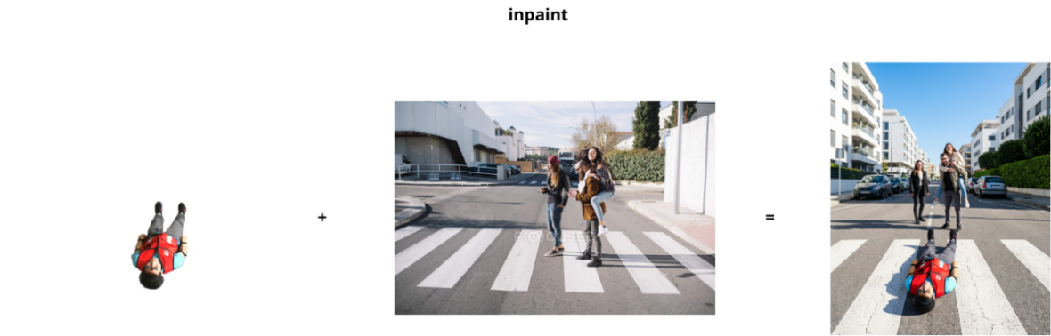

Results Analysis
The inpainting-based generative model demonstrates strong performance in creating physically plausible scenes. Depth consistency (0.363) and shading consistency (0.497) indicate good preservation of spatial structure and lighting adaptation, with minor inconsistencies in complex scenarios. Surface normals consistency is lower (0.031), highlighting some limitations in fine-grained geometric details around object boundaries. Perceptual quality, measured by a NIQE score of 3.158, is acceptable and reflects reasonable visual realism. Overall, the model effectively generates coherent fall and non-fall scenes, particularly in terms of lighting and global depth, and is best used as a complementary tool for synthetic dataset creation rather than a standalone solution.

Results – Stage 2: Evaluation of Fine Tuning LBFD-Net

Quantitative Results
Models | Accuracy | Precision | F1-Score | AUC
LBFD Net - Inpainting Dataset | 0.9222 | 0.9524 | 0.9195 | 0.94
LBFD Net -  Stable Diffusion Dataset | 0.8667 | 0.8113 | 0.8776 | 0.95
LBFD-Net -  Nano Banana Dataset | 0.8222 | 0.8222 | 0.8222 | 0.91
LBFD-Net -  all Datasets | 0.8037 | 0.9184 | 0.7725 | 0.93
Table 4: Evaluation of the models using dedicated test sets
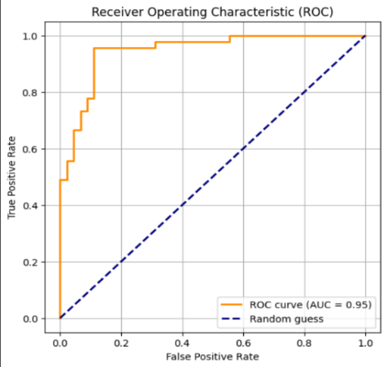
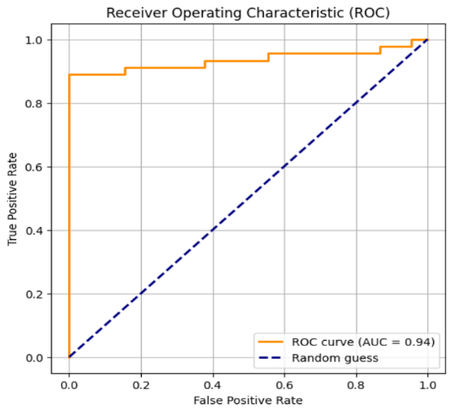
LBFD Net - Stable Diffusion

LBFD Net - Inpainting Dataset

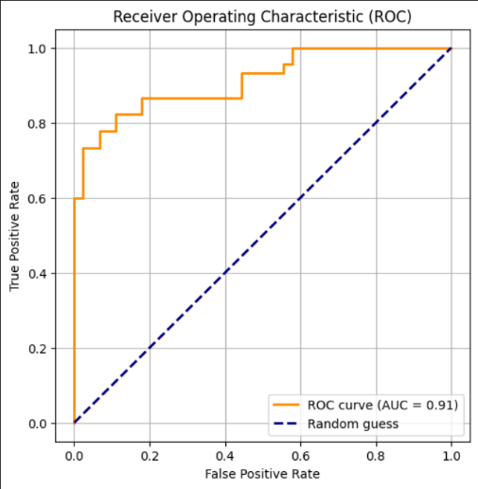
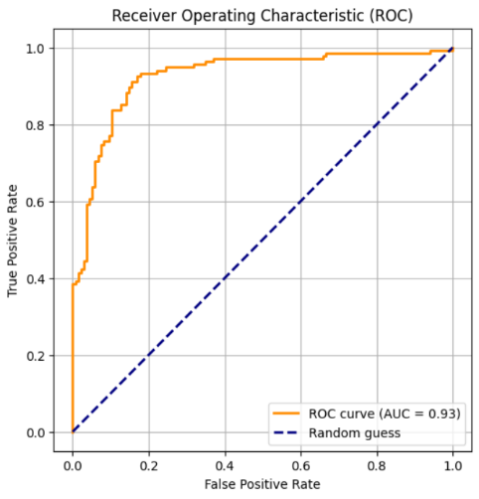
Figures 16-19: Evaluation of the models using dedicated test sets

LBFD Net - Nano Banana

LBFD Net - All Datasets

Results Analysis
Fine-tuning on the inpainting-based dataset yielded the best overall performance, achieving the highest accuracy, precision, and F1-score, and demonstrating strong alignment with both indoor and outdoor fall patterns. The Stable Diffusion-based model attained the highest AUC, indicating superior class separability despite slightly lower accuracy. In contrast, the Nano Banana-based model exhibited consistently lower performance, reflecting limited generalization relative to the other generative approaches. Training on the combined datasets led to performance degradation, likely due to domain mismatch and increased heterogeneity.

Quantitative Results
Models | Accuracy | Precision | F1-Score | AUC
LBFD Net - Inpainting Dataset | 0.8593 | 0.8760 | 0.8561 | 0.91
LBFD Net -  Stable Diffusion Dataset | 0.8111 | 0.7763 | 0.8223 | 0.87
LBFD-Net -  Nano Banana Dataset | 0.8111 | 0.8088 | 0.8118 | 0.90
Table 5: Evaluation of the models using general test set
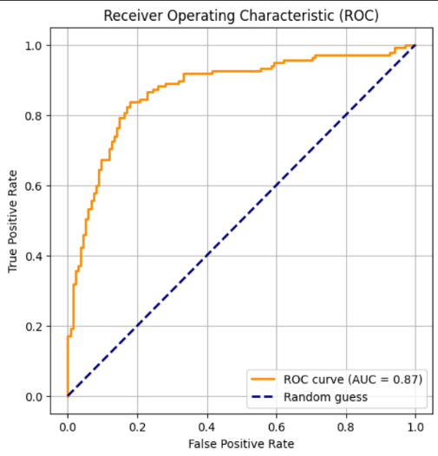
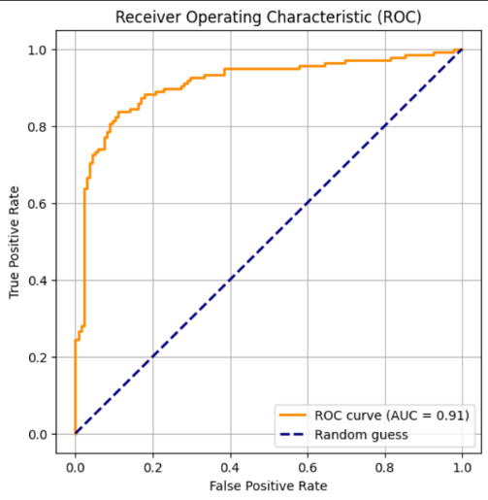
LBFD Net - Stable Diffusion

LBFD Net - Inpainting Dataset

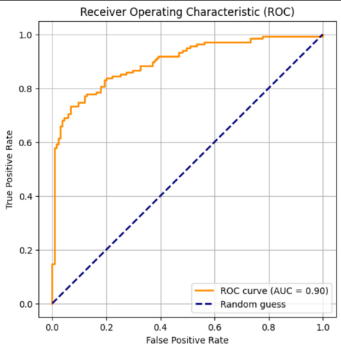
LBFD Net - Nano Banana

Figures 20-22: Evaluation of the models using general test set

Results Analysis
The evaluation on the general test set demonstrates clear differences in performance between the models fine-tuned on different synthetic datasets. Among all evaluated approaches, the LBFD-Net model fine-tuned on the Inpainting dataset achieved the best overall results, reaching the highest accuracy (0.8593), precision (0.8760), F1-score (0.8561), and a strong AUC value of 0.91. These results indicate that the inpainting-based synthetic data provided the most effective and reliable training samples, enabling the model to generalize better to a mixed test set consisting of both real indoor images and synthetic public-space images.
The model fine-tuned on the Stable Diffusion dataset showed lower performance across most metrics, achieving an accuracy of 0.8111 and an AUC of 0.87. Although Stable Diffusion is capable of generating visually diverse and realistic images, the performance gap suggests that the synthetic images produced by this method may introduce domain shift and structural inconsistencies that negatively affect the learning process. As a result, the model trained on this dataset demonstrated weaker generalization to the combined test domain.
Similarly, the Nano Banana–based model achieved comparable accuracy (0.8111) but slightly better AUC (0.90) than the Stable Diffusion model. However, its F1-score (0.8118) and precision (0.8088) remained noticeably lower than those of the Inpainting-based model. This outcome suggests that while Nano Banana images may be visually coherent, they do not align as well with the real data distribution required for effective fall detection, limiting their usefulness for fine-tuning LBFD-Net.
Overall, these results reinforce the conclusion that the quality and domain alignment of synthetic data are more critical than visual realism alone. The superior performance of the Inpainting-based approach indicates that preserving real scene structure and minimizing generative artifacts leads to more effective training data and, consequently, better model performance. In contrast, fully generative approaches, despite producing realistic-looking images, may introduce variability that reduces the model’s ability to generalize across real-world scenarios.

Conclusions and Discussion
This study examined the contribution of synthetic data to improving fall detection performance through fine-tuning of the LBFD-Net model. The main objective was to evaluate whether generative models can be used to bridge the gap between controlled laboratory datasets and realistic public-space scenarios, by generating synthetic images that simulate falls under diverse real-world conditions.
The experimental results clearly indicate that the type and quality of synthetic data have a substantial impact on model performance. Among all evaluated approaches, fine-tuning LBFD-Net using the Inpainting-based dataset consistently produced the best and most stable results. In the dedicated test set evaluation, this model achieved the highest Accuracy, Precision, and F1-score, demonstrating strong generalization to both real indoor images and synthetic images representing public environments.
The primary reason for the superiority of the Inpainting approach lies in its ability to preserve the structure of the original scene. In this method, the background is based on real images, and the generation process focuses solely on inserting a person into a predefined masked region. As a result, critical aspects such as natural lighting, perspective, textures, and environmental details remain unchanged. Unlike fully generative models that create entire scenes from scratch, Inpainting produces training samples that are much closer to the distribution of real-world data, enabling the model to learn task-relevant patterns more effectively and reliably.
Another significant advantage of the Inpainting approach is the reduction of generative hallucinations. General-purpose generative models, such as Stable Diffusion, may occasionally produce images containing anatomical distortions, inconsistent objects, or unrealistic spatial structures. Even minor artifacts of this kind can negatively affect the quality of training data and, consequently, the performance of classification networks. In contrast, Inpainting modifies only a small region of the image while leaving the majority untouched, resulting in cleaner, more coherent, and more trustworthy training samples. This characteristic directly contributed to the improved performance of the model trained on this dataset.
The model fine-tuned using the Stable Diffusion dataset achieved the highest AUC score, indicating strong class separability. However, its overall performance was lower compared to the Inpainting-based model. This finding suggests that although Stable Diffusion can generate diverse and visually realistic images, the large variability and domain shift introduced by this method may hinder the model’s ability to learn stable and consistent representations for fall detection.
The model trained on the Nano Banana dataset demonstrated the weakest performance among the evaluated approaches. While the generated images were visually coherent, they appeared to lack sufficient structural and contextual alignment with the target task, resulting in limited contribution to the discriminative capabilities of LBFD-Net.
An additional important finding is that training on a combination of all synthetic datasets led to performance degradation. The mixed-dataset model achieved the lowest F1-score, indicating that excessive diversity and heterogeneity across domains can negatively affect learning rather than improve it. This result highlights that simply increasing the amount of data is not sufficient; careful domain alignment between synthetic samples and the target application is essential.
The evaluation using the general test set, which combined real indoor images and synthetic samples, further reinforced these conclusions. Once again, the Inpainting-based model delivered the most balanced and consistent performance, confirming that this approach represents the most effective strategy for generating synthetic data for fall detection.

Limitations
Despite the promising findings, several limitations should be acknowledged. First, the study relied primarily on synthetic representations of public-space falls, as real-world datasets of this nature are currently unavailable. Second, computational and budget constraints limited the scale of image generation and experimentation. Finally, the study focused exclusively on the LBFD-Net architecture, and results may vary when applied to alternative fall detection models.

Future Works
Several directions can be explored to further extend and strengthen this research.
First, expanding the synthetic datasets to include a larger number of scenes, camera angles, and environmental conditions could improve the robustness and generalization capabilities of the trained models.
Second, future studies should aim to collect and evaluate real-world fall data from public spaces, if such data becomes available. Testing the models on genuine outdoor footage would provide a more realistic assessment of their practical applicability and help validate the effectiveness of synthetic training data.
Finally, the same research methodology can be applied to alternative fall detection approaches, such as skeleton-based estimation and pose-analysis methods. Investigating whether generative data augmentation provides similar benefits for these techniques would contribute to a more comprehensive understanding of how synthetic data can support fall detection systems.

Final Remarks
The results of this research demonstrate that synthetic data can serve as an effective tool for enhancing fall detection systems, provided that the data are generated using appropriate and task-aware methods. The Inpainting approach proved to be the most successful strategy due to its ability to preserve real scene structure and avoid common generative hallucination issues. These findings emphasize the importance of domain-aware synthetic data generation, particularly in safety-critical computer vision applications.

References
- Gaya-Morey, F. X., Manresa-Yee, C., & Buades-Rubio, J. M. (2024). Deep learning for computer vision based activity recognition and fall detection of the elderly: a systematic review. arXiv preprint arXiv:2401.11790.

- Jamal, S., Wimmer, H., & Rebman Jr, C. M. (2024). Perception and evaluation of text-to-image generative AI models: a comparative study of DALL-E, Google Imagen, GROK, and Stable Diffusion. Issues in Information Systems, 25(2), 277-292.‏

- Song, Y., Zhang, Z., Lin, Z., Cohen, S., Price, B., Zhang, J., ... & Aliaga, D. (2024). Imprint: Generative object compositing by learning identity-preserving representation. In Proceedings of the IEEE/CVF Conference on Computer Vision and Pattern Recognition (pp. 8048-8058).‏

- ‏Zhang, Y., Zheng, X., Liang, W., Zhang, S., & Yuan, X. (2022). Visual surveillance for human fall detection in healthcare IoT. IEEE MultiMedia, 29(1), 36-46.‏

- Zi, X., Chaturvedi, K., Braytee, A., Li, J., & Prasad, M. (2023). Detecting human falls in poor lighting: Object detection and tracking approach for indoor safety. Electronics, 12(5), 1259.‏

- Nabizade, M., Nacer, N., Lajoie, I., Yahiaoui, R., Auber, F., & Fayad, M. (2025, August). Fall Detection Using LBFD-Net: A Novel CNN-Based Architecture. In 2025 International Conference on Artificial Intelligence, Computer, Data Sciences and Applications (ACDSA) (pp. 1-6). IEEE.‏

